**Analysis of Daily Weather Readings from CVG Between 1950-2019**

**By Matthew Staudigel**

**Introduction to Programming in Python and R**

**Professor Joni Torsella**

**Introduction**

Weather data has been captured by the Northern Kentucky International Airport (CVG) for several decades to determine the daily weather patterns, temperatures, and precipitation levels for suitable flying. The FAA, or the Federal Aviation Administration, mandated large airports in the United States to do so in order to increase the safety of passengers and flights. Due to this mandate, there is a massive amount of daily weather data spanning back decades that we can analyze.

**Proposal**

The NOAA (National Oceanic and Atmospheric Administration) has recorded daily weather data at CVG dating back to 1950. For nearly everyday since January 1st, 1950, the high temperature, the low temperature, the precipitation levels of each day, and the snow levels of each day. On the available amount of data from the NOAA, there are over 25,000 daily observations to use.

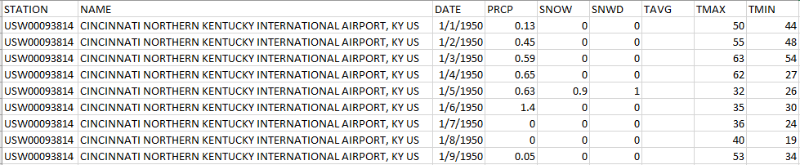

Figure 1: Small portion of the weather data CSV dump from the NOAA

The dataset supplied by the NOAA contains the weather station name (CVG airport), the date of the observation, the precipitation (rain or sleet in inches) measurement of that day, the snow levels of that day in inches, the high temperature of the day and the low temperature of the day. The dataset was obtained via a request to the NOAA.

Link to data: <https://www.ncdc.noaa.gov/cdoweb/datasets/GHCND/stations/GHCND:USW00093814/detail>

NOTE: The CSV file containing the data will be submitted in addition to this project proposal.

The goal of this project is to analyze weather data at CVG across 68.5 years to discover temperature trends and precipitation trends using Python. The following are analyses that will be targeted:

* Hottest high temperature readings of each year
* Coldest low temperature readings of each year
* Average temperature of each year
* Precipitation totals of each year
* Average yearly precipitation for Cincinnati
* Snow totals of each year
* Average yearly snow amounts for Cincinnati
* Wettest day of each year
* Highest snow total of each year
* Use the above observations to predict future readings and levels